**C:\Users\Caroline\AppData\Local\Microsoft\Windows\Temporary Internet Files\Content.IE5\7Y9D1L0C\MCj03656620000[1].wmfStatistics HomeworkNational 4/5 Lifeskills**

1. A group of pupils at Forfar Academy were asked how much money they spent on their lunch everyday, the results were as follows:

£1.50, £2.50, £2.00, £2.00, £3.00, £2.50, £0.50, £2.00, £4.50, £1.50, £1.00, £2.00, £1.00

C:\Users\Caroline\AppData\Local\Microsoft\Windows\Temporary Internet Files\Content.IE5\FFKLF2LF\MCj02958540000[1].wmf

1. Calculate the MEAN amount of lunch money spent
2. What was the MEDIAN?
3. What was the MODAL amount? (the mode)
4. What was the RANGE of lunch money spent?
5. The data below shows the number of buses that go through Forfar High Street each day in June:



16, 14, 23, 24, 15, 22, 23, 18, 13, 16, 18, 17, 16, 24, 21, 17, 13, 18, 11, 25, 21, 16, 16, 18, 17, 23, 23, 13, 17, 15,

11, 52, 24, 15, 10

1. Construct a frequency table like the one below:

|  |  |  |
| --- | --- | --- |
| No of buses | Tally | C:\Users\Caroline\AppData\Local\Microsoft\Windows\Temporary Internet Files\Content.IE5\UJD2R2XC\MCj03634440000[1].wmfFrequency |
|  |  |  |
|  |  |  |

1. Use this to draw a bar chart
2. Second year test scores are shown in the table below:

|  |  |  |
| --- | --- | --- |
| **S2 Scores ($x)$** | **Frequency (f)** | **F x $x$** |
| 12 | 1 |  |
| 14 | 6 |  |
| 16 | 8 |  |
| 18 | 9 |  |
| 20 | 6 |  |
| Totals |  |  |

1. Copy and Complete the table above
2. Using the table calculate the MEAN test score for S2
3. What was the modal score in the test (mode)?
4. C:\Program Files (x86)\Microsoft Office\MEDIA\CAGCAT10\j0293828.wmfThe amount of rainfall recorded for a week in March (seven days) in **Forfar** was

8cm, 3cm, 4.5cm, 7cm, 9.8cm, 5cm and 9cm

The amount of rainfall recorded for a week in March (seven days) in **Glasgow** was

9cm, 10.9cm, 11cm, 8cm, 9.2cm, 11.2cm and 10cm

(a) Calculate the mean amount of rainfall for (i) Forfar and (ii) Glasgow for a week in March.

(b) Calculate the range of rainfall for (i) Forfar and (ii) Glasgow for a week in March.

(c) Make two comments about the amount of rainfall in Forfar and Glasgow.

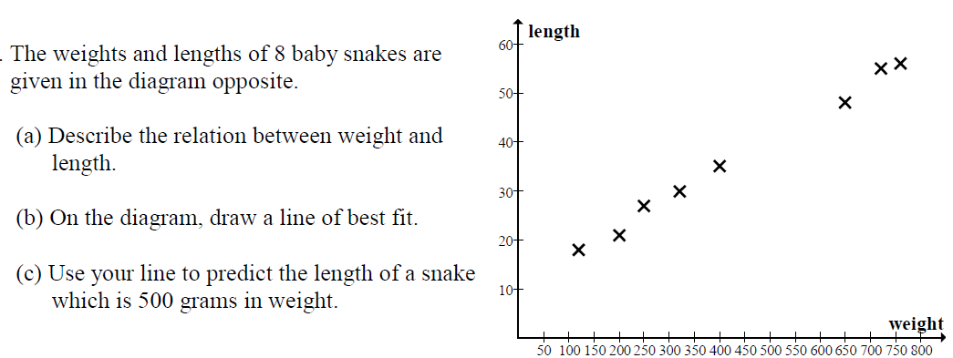

5.

6. 