**C:\Documents and Settings\FORCARSTAIRSL\Local Settings\Temporary Internet Files\Content.IE5\L8EAF1VP\MC900048382[1].wmfStandard Deviation Exam Style Q’s**

2001

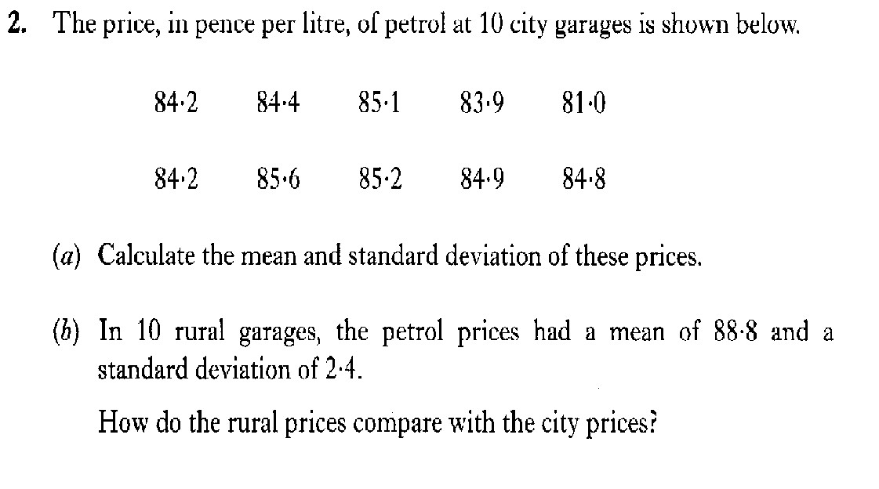

**3**

**2**

2003

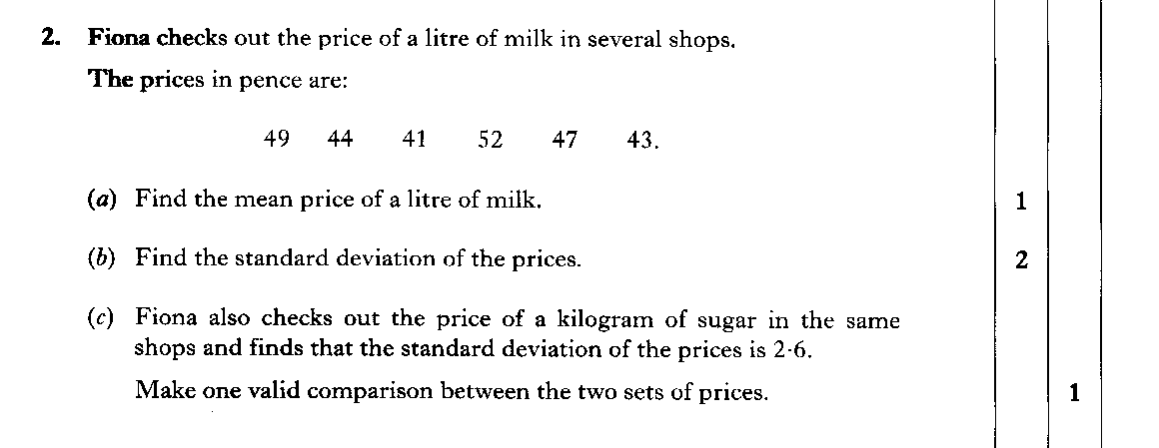

2004

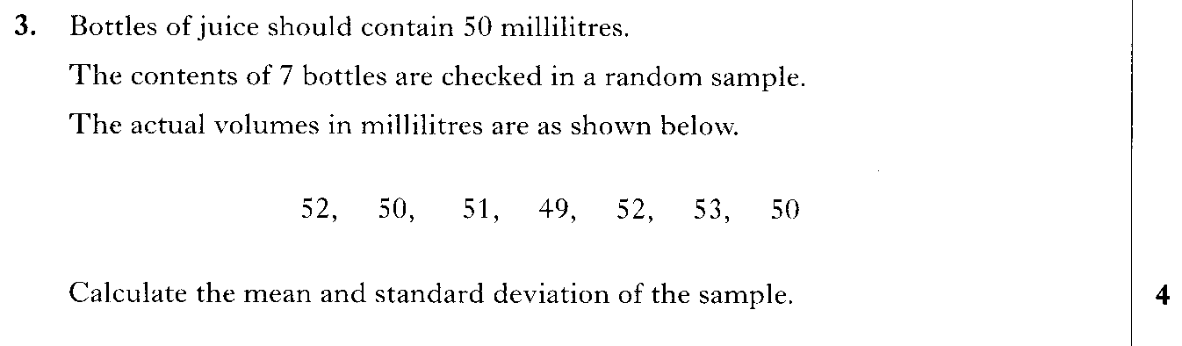

**2005**

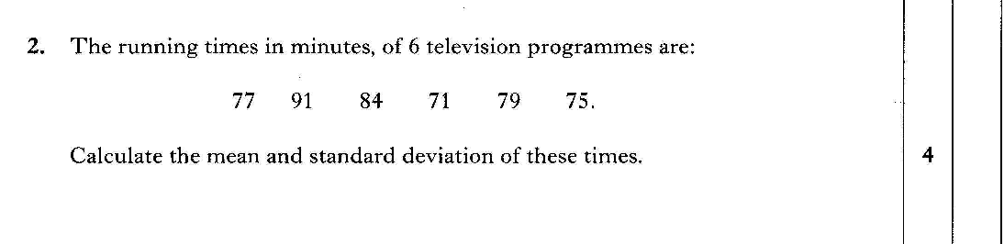

**2006**

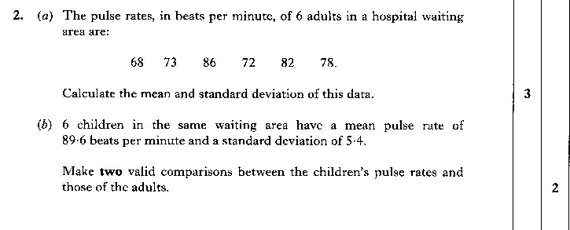

**2007**

