Solve the following equations using the balancing method making sure all your working is shown.
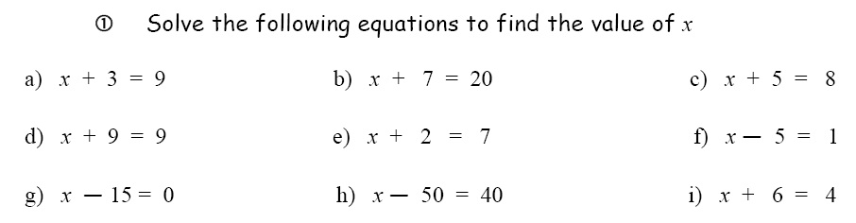

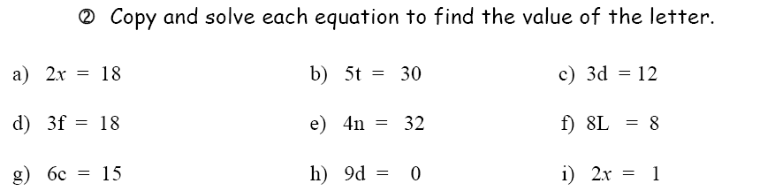
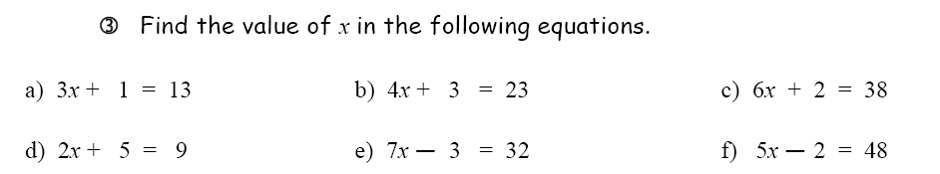

5. Find the answer to the following substitution questions:
a) 2p, if p = 6
b) 2n + 1, if n = 2
c) 6x-2, if x = 1
d) q + 4, if q = 10
e) $e^{2}$ if e = 6
f) a(b + 3) if a = 5 and b = - 2

