2007 CREDIT PAST PAPER

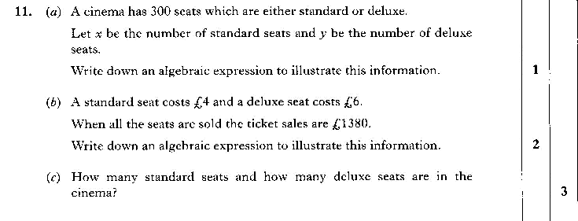

Volume Q (2006 Credit)

