1. A square based prism has a volume of 64. Calculate the base.

2. The radius of the Earth’s orbit is 9.3 x miles. Calculate:

1. the diameter
2. the circumference of the orbit, giving your answer in **standard form**.

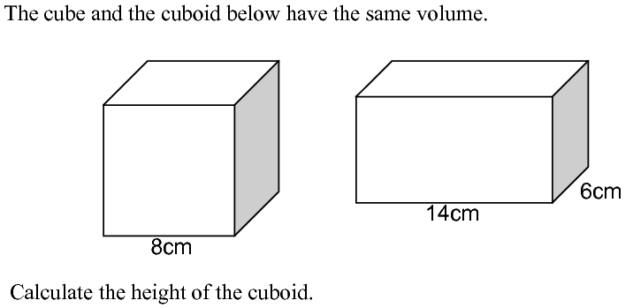



3.

c.

a.

b.

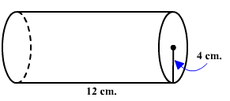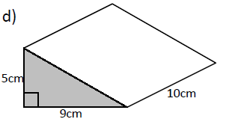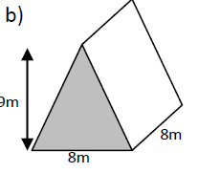

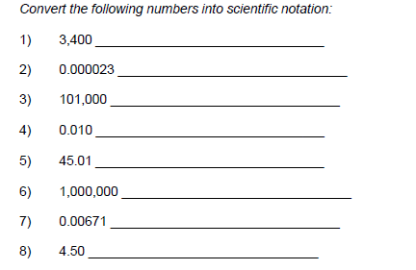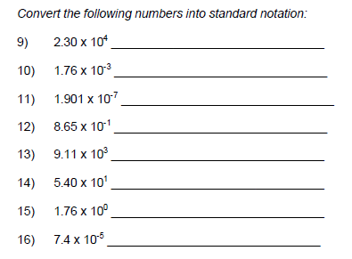

4.

1. A square based prism has a volume of 64. Calculate the base.

2. The radius of the Earth’s orbit is 9.3 x miles. Calculate:

1. the diameter
2. the circumference of the orbit, giving your answer in **standard form**.





3.

c.

a.

b.





4.