Forfar Academy Mathematics Department
Remember to show all you working:

- Which offer is the best value (think about the area of pizza you will eat)? Why?
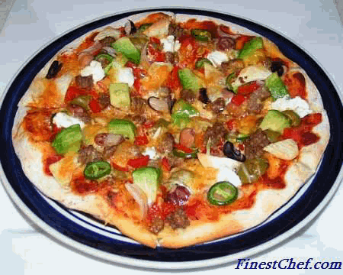
1 x 30 cm (diameter) pizza for £14.99 | 2 x 18 cm (diameter) pizzas for £14.99

- What is the relationship between the radius and the diameter of a circle?

- . Calculate the perimeter of the logo below:
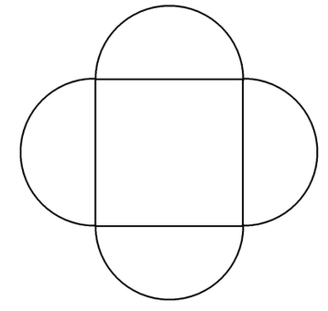

3 cm

- Find the shaded area:  4 cm | - Find the area and circumference of this circle:
 | 1.7 cm
6. How long would it take to travel 260 miles at an average speed of 40mph? Without a calculator – show all working!

7. Calculate the average speed of a car that travels 198 km in 2hours and 15 minutes.

