Financial Meltdown – Your Final Challenge
You have each been given an occupation following lessons on wages and salaries and you have gathered information on your earnings/salary.
You will now have to make various decisions based on this. (Monthly – food, bills, luxuries
Good luck surviving the financial meltdown!

Task 1 – a place to stay
Using your earnings after deductions figure you have to decide on a place to stay. If you stay at home you should look into moving out and use this as a chance to see if you could budget effectively.
- If you earn an annual salary of over £30,000 then you should look into buying a home.
- If you earn an annual salary under £30,000 then you should consider one of the options to rent.
Each option includes how much you will have to pay on bills each month. This includes things like council tax, gas and electricity, and internet/sky.

Renting Options
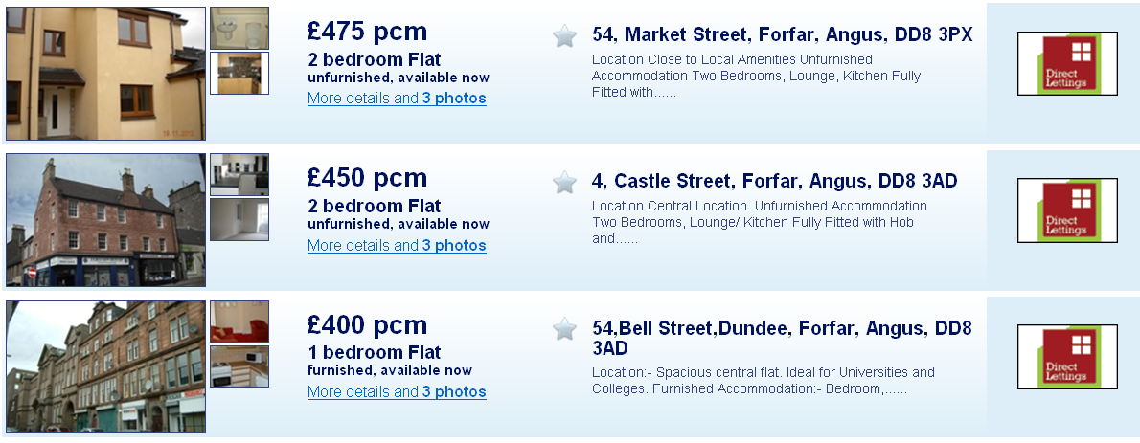
Forfar
Bills
£135pm

Bills
£115pm

Bills
£75pm

Dundee
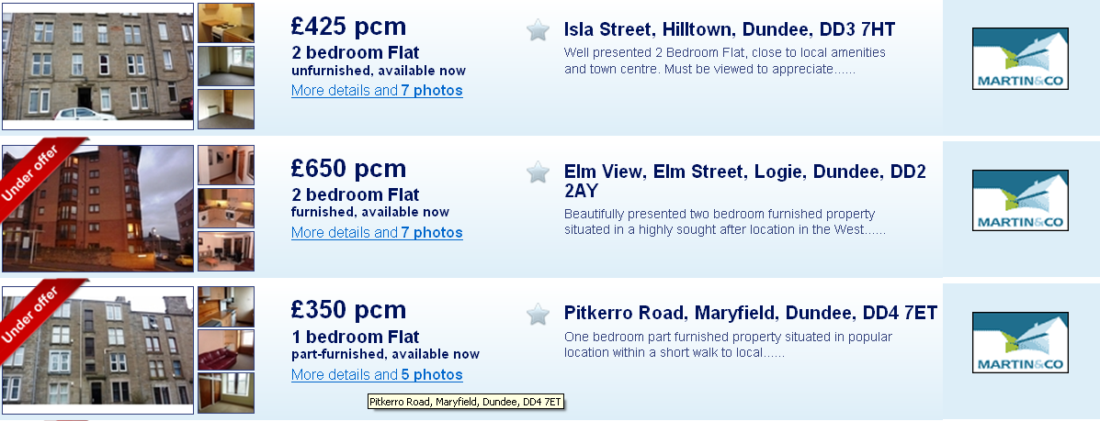
Bills
£162pm
Bills
£78pm
Bills
£98pm

Mortgages
Forfar
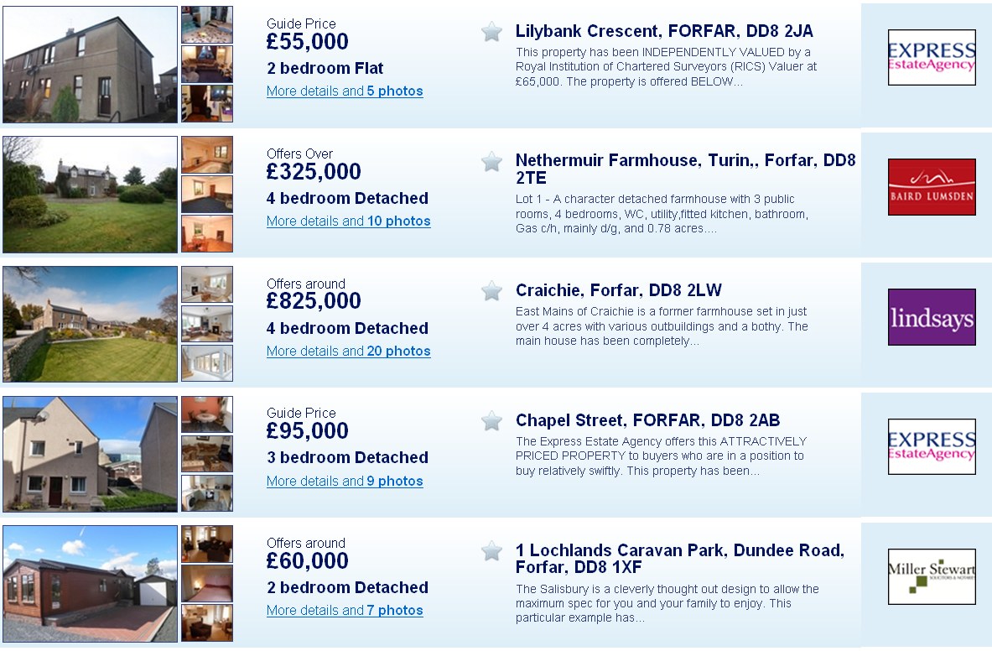
Bills
£98pm
Bills
£118pm
Bills
£398pm
Bills
£168pm
Bills
£123pm

Dundee
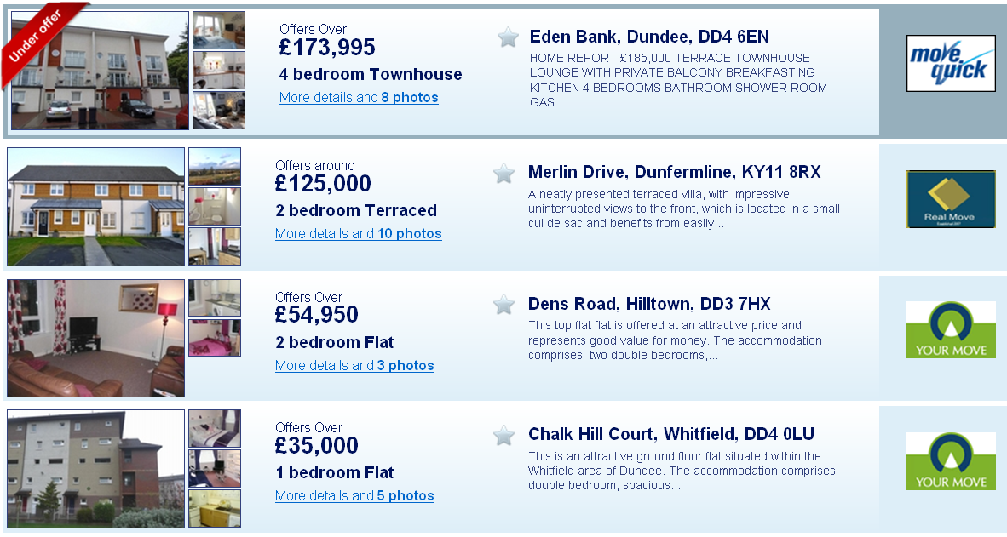
Bills
£98pm
Bills
£76pm
Bills
£273pm
Bills
£216pm

Using the table below (based on a 5% apr) the monthly repayments for the above mortgages would be:
 | £35,000 | £54, 950 | £55,000 | £60,000 | £95, 000 | £125,000 | £173,995 | £325,000 | £825,000
15 years | 281 | 440.77 | 441.57 | 481.71 | 762.71 | 1003.57 | 1396.92 | 2609.27 | 6623.53
20 years | 234.04 | 367.11 | 367.78 | 401.21 | 635.25 | 835.86 | 1163.48 | 2173.24 | 5516.68
25 years | 206.94 | 324.61 | 325.2 | 354.76 | 561.71 | 739.09 | 1028.78 | 1921.63 | 4877.98

Most people generally chose to pay back their mortgage back over 25 years so you should choose this option.

Task 2 – Food
The items on the shopping list below are all classed as items on a weekly “basic shop”. You should price each of these products using Tesco online shopping. The make of the food you buy is entirely up to you (smart price, asda’s finest etc). You should take into consideration your monthly income considering this. Please write down exactly how much you spend on each item. You should multiply this by 4 to get a rough estimate for a monthly shop.
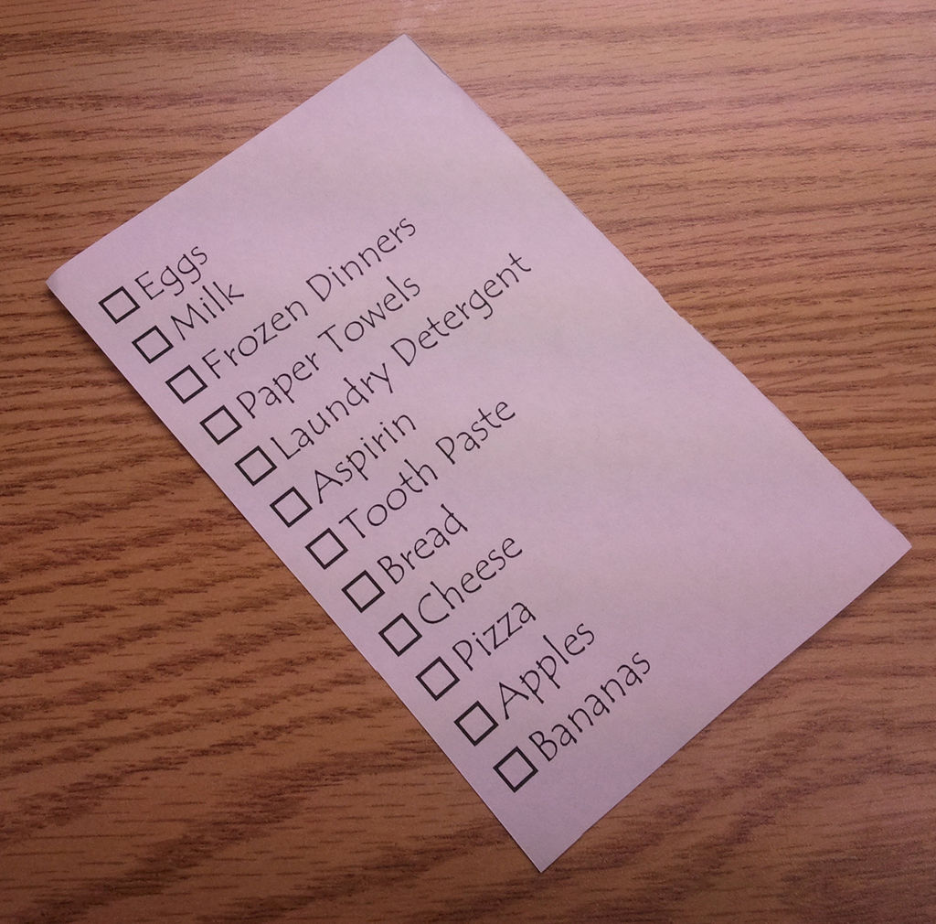
Basic Shop
Eggs
Milk
Cheese
Bread
Apples
Bananas
Cereal
Toilet paper

Toothpaste
Washing Powder
Pasta
Tin of Beans
Frozen broccoli
Peppers
Frozen dinners x 3
Biscuits

Luxuries
Once you have paid for all your essentials you are now able to spend what you like on luxuries. You should pick some of the activities to take part in such as:

Eating out | £20 per outing | Go-Karting | £24 per person
Gym Class | £5.25 per class | Football game | £20 per game
Cinema | £7.95 per person | Savings | *Decide on the amount you want to save
Night out | £30 per person | Concert/Theatre trip | £35

Final Task
You should now start to write up your report showing exactly what you would spend on rent/mortgage, food, and luxuries. You should make a conclusion about your standard of living based on the money you will have left. You might want to include what you would chose to do with you money you have left over.

