1. A supermarket stores cartons of juice in large storage boxes. A large storage box has the dimensions as follows:
5m
2m
6m

The cartons MUST be stored this way up and have the dimensions as follows:
20cm
50cm
15cm

What is the maximum amount of cartons can be stored in the large container?
Justify your answer.
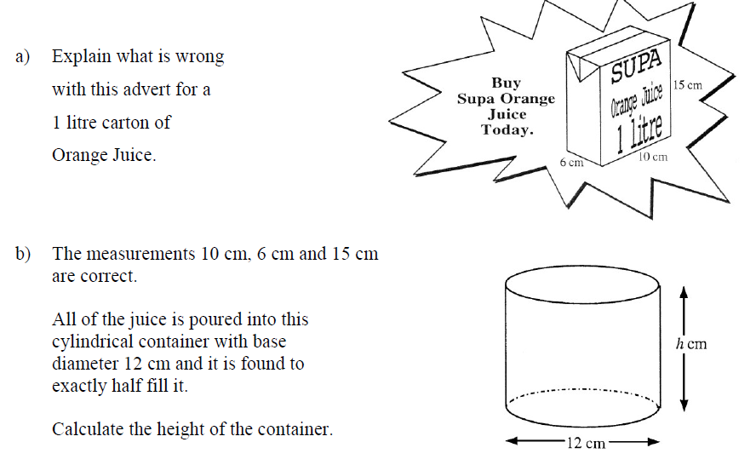
2.
3.

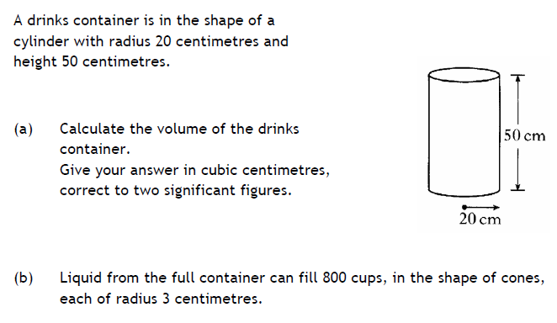
3.

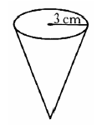

What will the height of liquid be in each cup?

4. Calculate the perimeter of this shape, where OBC is a quarter of a circle of radius 4m
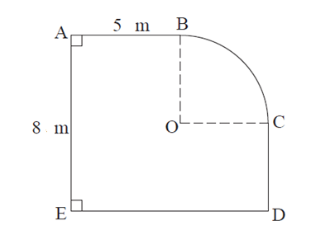
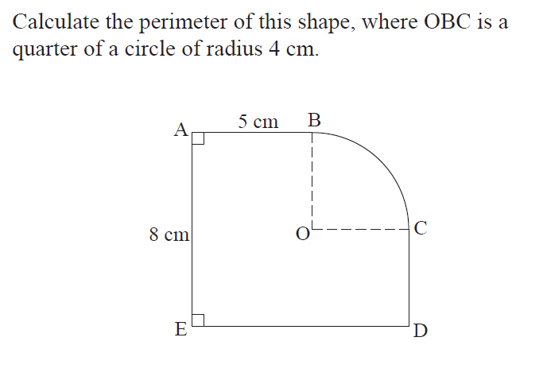
5. Mr Smith has a living room in the shape of ABCDE above and wants to lay a carpet down.

- Calculate the total area which requires to be carpeted?
- The carpet he wants is priced at the following prices in two stores:

Smalls charges £7.45 per square metre
Shorts charges £33.50 per 5 square metres

Where is he cheaper to buy the carpet?

(d) Using your recommendation, work out the cost of carpeting his room.

(e) Mr Smith wants to lay skirting around the room. What length of skirting will he require?

