1. Miss Carstairs is going on holiday to New York from Glasgow. She has the following information **available to her:**

|  |  |
| --- | --- |
| **Distance to new York** | 5246 km |
| **Aircraft Speed** | 920km/hr |
| **Time difference** | -5 hours (minus 5 hours) |
| **Stopover in Amsterdam** | 2 hours and 45 minutes |

(a) Calculate how long the journey from Glasgow to New york airport will take including the stopover in Amsterdam. Give your answer in hours and minutes.

(b) If Miss Carstairs takes the flight leaving Glasgow at 1330, what time will she arrive in New York (their time)?

(c) Miss Tindall, who lives in Forfar, plans to phone and chat to Miss Carstairs at 1000 UK time. Will this be a suitable time to phone? Justify your answer.

(d)Miss Carstairs will be teaching from 0900-1700 Monday to Friday. She likes to be in bed at night by 2230. Advise Miss Tindall on the best time to contact her on weekdays from her home in Forfar.

2. A boat sails from Helensburgh to the Isle of Bute. It makes one additional stops along the way to pick up passengers in Weymss Bay. Its Route is as follows:

From Helensburgh the boat sails 160 km on a bearing of 056° to Weymss Bay.

Then

40km on a bearing of 270° to the Isle of Bute.

(a) Using a suitable scale, make a scale drawing of the boats route.

(b) From the Isle of Bute the boat returns directly to Helensburgh. Calculate the distance of the distance of the return journey.

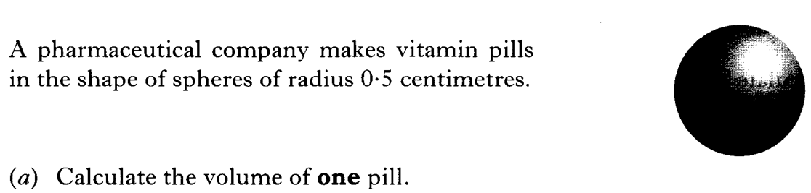(c) If the boat sails at a steady pace of 70km/hour ± 20% calculate the minimum and maximum time taken to complete the whole journey.

3.

**Volume of a Sphere is given by the formula: $\frac{4}{3}πr^{3}$**

**(b) How many pills can be made from a solution of 2 litres (poured into moulds)?**

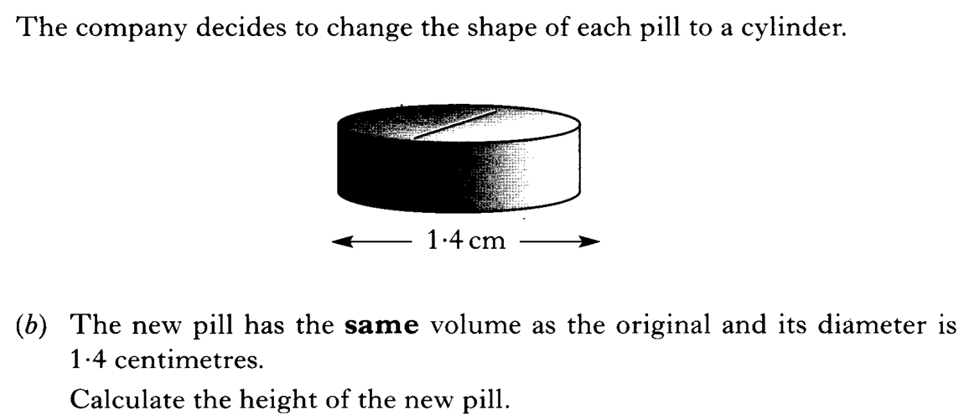**(c)**

4. A supermarket stores boxes of cereals in large storage boxes. A large storage box has the dimensions as follows:

2m

3m

4m

The cereal boxes MUST be stored this way up and have the dimensions as follows:

30cm

40cm

20cm

What is the maximum amount of cereal boxes can be stored in the large container?

Justify your answer.

5.

(a)Put the following tasks in order:

* Add milk and eggs
* Read the instructions
* Place in a cooking dish
* Preheat oven
* Ice the cake when cold
* Cook the cake
* Beat the misture
* Tip the contents of packet into a bowl.

(b) State two activities which can be performed at the same time.

6. New projectors are to be installed in the new school. They are to be attached to the ceiling using support posts as follows:

Drawing not done to scale.

D

F

3.7m

C:\Users\Lindsay\AppData\Local\Microsoft\Windows\Temporary Internet Files\Content.IE5\4YCBFCNJ\MC900282528[1].wmf

5m

4. 5m

E

(a) Calculate the gradient of each of the rods from D to the projector (E) and then from F to the projector (E).

7. Joe plans to paint his bedroom walls.

2.5 m

3·5 m

1 m

1 m

2.5 m

6 m

10 m

Paint: 1 litre tin covers 12 m²

(a) Calculate the total area of walls which require painting?

(b) What volume of paint must Joe buy to cover all the walls?

(c) How many tins will he need to buy?

(d) Paint is sold in 1 litre tubs which cost £7.75 or 3.5 litre tubs at £22.50. What is the minimum cost to decorate his room?

(e) Joe wants to put a border around the room (excluding the window and door). What length of boarder will he require?

(f) Joe’s mum wants to knit a semi circle rug for his door to save his carpet getting dirty. The dimensions of the rug would be as follows:

1m

[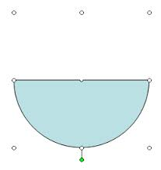](http://www.google.co.uk/url?sa=i&rct=j&q=&esrc=s&source=images&cd=&cad=rja&uact=8&docid=g30yHEdys-pE-M&tbnid=JVBJWLo3kkZFeM:&ved=0CAUQjRw&url=http://www.indezine.com/products/powerpoint/learn/shapes/halfcircleinpowerpoint2003.html&ei=so48U5ONIebM0QXnh4EI&bvm=bv.63934634,d.ZGU&psig=AFQjCNEJkjOtC8YxhU0GY7RfajX8J31FRg&ust=1396563989133225)

To knit it will cost £3.50 per square metre. Calculate the cost to knit the rug.