Numeracy National 5 Revision
1. Forfar Academy’s London trip runs from the 2nd-5th of October. The school travel to London via Train from Dundee. They will have to book a number of carriages on the train depending on the number of people on the trip. Each carriage holds 10 people. The school has recommended standard carriages to keep costs to a minimum.
There are 32 pupils on the group. 10 under 16’s and the rest are 17 or 18.
The adult to pupil ratio must be 1:7. All staff attending the trip are under over 30 years old and under 60 years old.
London is Approximately 364 miles to Dundee.
Accommodation (price per person per night)
 | May/Jun | July/Aug | Sept/Oct
Adult | £56 | £87 | £70
Young Student (16 - 21) | £45 | £72 | £63
Child (Under 16) | £40 | £68 | £59
Senior Citizen (60+) | £40 | £68 | £59

Train Price
Carriage | Journey ≥250 miles | Journey < 250 miles
Standard (single) | £485 | £367
2nd Class (single) | £498 | £373
First Class (single) | £525 | £495

Q1. Use the data provided on the previous page to answer the following questions.
(a) What is the minimum number of adults required to go on the London trip?
(b) Calculate the total cost of travel and accommodation?
(c) The school fund has agreed to pay 18.5% of the cost of the travel and accommodation. Staff accompanying the children do not pay anything for the trip. How much will the pupils each have to pay each to cover the remaining cost of the trip? Give you answer to the nearest penny.
2 . You are a travel advisor and you are planning a trip for two American tourists to visit the Isle of Bute.
This is the itinerary for the tourists:

Itinerary
Collect hire car and drive from Glasgow to Helensburgh
1 night in Helensburgh
Drive from Helenburgh to Arrochar
Stay 3 nights in Arrochar
Drive from Arrochar to Wemyss Bay to catch the ferry to Rothesay in the isle of Bute
Stay 1 night in Rothesay
Tour around the Isle of Bute
Catch ferry from Rothesay back to Wemyss Bay
Drive from Wemyss Bay back to Glasgow for a final night’s stay
Drive back to Glasgow Airport for flight home

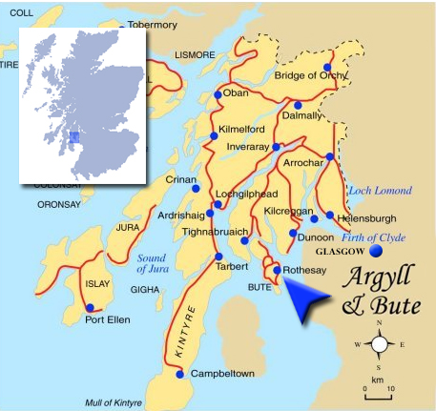
*Map Source (http://www.esplanadebute.com/location.html)
(a) Use the Map of Argyll and Bute to calculate the straight-line distance in km, from Glasgow to Rothesay on the Isle of Bute. Give your answer in km.

(b) Use the Extract from the Caledonian MacBrayne ferry timetable and the itinerary to calculate the cheapest way for a car and two adults to travel by ferry between Weyms Bay and Rothesay. Use your working to justify your answer.
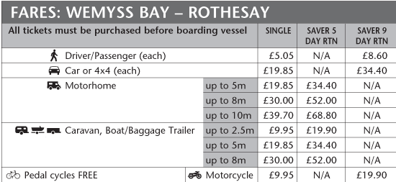
Additional Island Hopscotch Ticket (which allows passengers to travel between Wemyss Bay, Rothesay, Colintraive and Rhubodach).
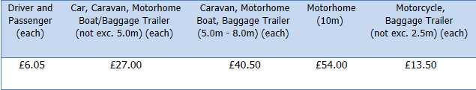

(c) The tourists will drive from Helensburgh to Arrochar for lunch with friends booked for 13:00. You know that some of the roads on this route can only be driven at an average speed of 30 mph. The distance from Helensburgh to Arrochar is 19 miles. Estimate their journey time in minutes.
(d) Using your answer to (c), advise the couple what time they should depart Helensburgh to arrive in Arrochar in time for lunch. They need to pick up a present from the Jewellers on the way. This will take approximately 15 minutes.
What time should they leave Helensburgh to arrive on time for lunch? Use your working to justify your answer.
3 The graph below shows the amount of carbon dioxide in the atmosphere.
(Data source: NOAA/ESRL.)

(a) Assuming that the trend continues as shown on the graph above, estimate when the amount of carbon dioxide in the atmosphere will reach 395 ppm (parts per million). (hint – use a ruler to mark a line at 395ppm and extend your graph)

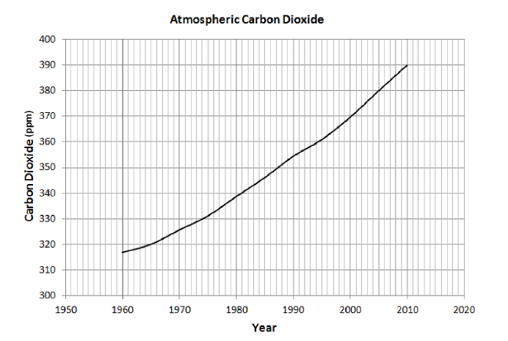
(b) Calculate the percentage increase in carbon dioxide from 2000 to 2010. Give your answer to 2 significant figures.

(c) The percentage increase in carbon dioxide from 1980 to 1990 is 4·4% Some scientists stated that this is double the percentage increase from 1960 to 1970. Are they correct? Use your calculations to justify your answer.

(d) In a survey, 700 people said they were willing to try and reduce the amount of carbon dioxide they produce. If this was two thirds of the people in the survey, how many people were in the survey altogether?

4. A company wants to know why most travellers come to Edinburgh type of accommodation. The results of a survey on the passengers arriving at Edinburgh Airport are shown in the table below:

Reason for Travel | Age 0-39 | Aged 40+ | Total
Sports | 23 | 164 | 187
Sight Seeing | 115 | 140 | 255
Family | 42 | 120 | 162
Weather | 20 | 71 | 91
Total | 200 | 495 | 695

(a) What is the probability that someone arriving at the airport, who travelled to visit family, (selected at random), is aged over 40? Give your answer as a fraction.
(b) “Most people under 40 visit Edinburgh to sight see, whereas most people 40 years of age and over visit for sport.”

Comment on this statement with regards to how accurate it is. You will need to use working to justify your answer.

Answers
Question 1
(a) Adult ratio is 1 : 7 = minimum 5 in total
(b) Accommodation = £4158
Cost for adults = 3 at £70 = £210 per person. 5 adults = £1050
Children aged under 16 = 3 at £59 = £177 per person. 10 pupils = £1770
Young students 3 x £63 = £189. 22 pupils £4158
Total cost = £1050 + £1770 + £4158 = £4158
Travel = £2880
Total number of passengers = 37
Carriages required 37 ÷ 10 = 4
Journey ≥250
Cost of 48 seat for return journey = £480 × 4 = £1940 (single) x 2 = £2880 for a return
Total cost = £4158 + £2880 = £7336
(c) Amount to be paid per pupil = £251.07
PTA pay 18·5% of £9858 = £1823.73
Amount required = 9858 –1823.73 = £8034.27
8034.27 ÷ 32 = £251.0709
Question 2
(a) 1.9cm±0.2 = 38Km (accept 34km-42km)
(b) Car return = £34.40
Passengers return = £8.60 x 2 = £17.20
Total cost using return tickets = £51.60
Car single = 19.85 × 2 = 39.70
Passengers single = 5.05 × 4 = £20.20
Total cost using single tickets = £59.90
Hopscotch Ticket costs £6.05 x 2 = £12.10 + £27.00 = £39.10
Island hopscotch is therefore the cheapest method of travel to isle of bute by (£59.90 - £39.50) £20.80
(c) Use speed time distance formula.
Time = distance ÷ speed = 19/30 = 0.633 hours = 38 minutes
(d) 15 mins +38 mins = 53 mins
13.00 –53 mins
Leave no later than 53 minutes past 12:00 (noon) (12:07)
Question 3
(a) 2012- 2013 acceptable
(b) 5.4% (accept ± 0·5%)
2000 – 370
2010 – 390
Percentage increase =
20/370 x 100 = 5.4%
(c) 1980 – 1990 = 354 - 339 = 15
15/339 x 100 = 4.4%
1960 – 1970 = 326 - 317 = 9
9/317 x 100 = 2.8%
Double the increase between 1960-1970 would be (2.8% x 2 =) 5.6% therefore the scientists are not correct.
(d) 1050 people
700 ÷ 2 x 3 = 1050
Question 4
(a) Probability = 120/162 (20/27 simplified)
(b) The statement is true for business travellers but not true for tourists.
Probability of people aged 0 – 40 who travel to sight see = 115/200
Probability of people aged 40+ travel for sport = 164/495
To compare these we can convert to percentages.
Percentage of people aged 0 – 40 who travel to sight see = 115/200 x 100 = 57.5% (over half)
Percentage of people aged 40+ travel for sport = 164/495 x 100 = 33.1% (under 50%)
By comparing the percentages it is easy to see that most people under 40 do travel to Edinburgh for sightseeing (over 50%).
Only 33.1% of people aged 40 and over visit Edinburgh for sport. This is under 50%. The percentages of people visiting for sightseeing in this age category is also high (28%)

