NATIONAL 5 MATHEMATICS EXPRESSION AND FORMULA UNIT 1 PRACTICE NAB 2

Assessment Standard 1.1

Q1. |  | Simplify, giving your answer in surd form:  √75 | (2)
Q2. |  | Simplify:
 | (a) | (i) $\frac{y^{4} × y^{5}}{y^{3}}$ | (2)
 |  | (ii) ${3a}^{\frac{5}{2}} × {4a}^{-\frac{3}{2}}$ | (2)
 | (b) | There are 3.156 x 10⁷ seconds in a solar year. How many seconds are there in 5 solar years? | (2)
 |  | Assessment Standard 1.2
Q3. |  | Expand and simplify where appropriate:
 | a) | 9(3x – y) | (1)
 | b) | (x + 5)(x + 2) | (2)
Q4. |  | Factorise:
 | a) | x² – 8x | (1)
 | b) | p² – 36 | (1)
 | c) | x² + 9x + 14 | (2)
Q5 |  | Express $x^{2}+6x+11$ in the form ${(x+b)}^{2}+c$ . | (2)
 |  | Assessment Standard 1.3
Q6 |  | Write $\frac{(7x-3)(x+11)}{{(x+11)}^{2}}$ , $x ≠ -11$  in its simplest form. | (1)
Q7 |  | Write each of the following as a single fraction:
 | (a) | $x , y ≠0$ | (2)
 | (b) | , $p , r ≠0$ | (2)
 |  | Assessment Standard 1.4
Q8 |  | A is the point ( -4 , -1 ) and B is the point ( 2 , 10 ).  Calculate the gradient of line AB. | (2)
Q9 |  | The zorbing sphere shown has a radius of 1.5m. Calculate the volume of water that is needed to clean the inside, giving your answer to 2 significant figures.
 |  | 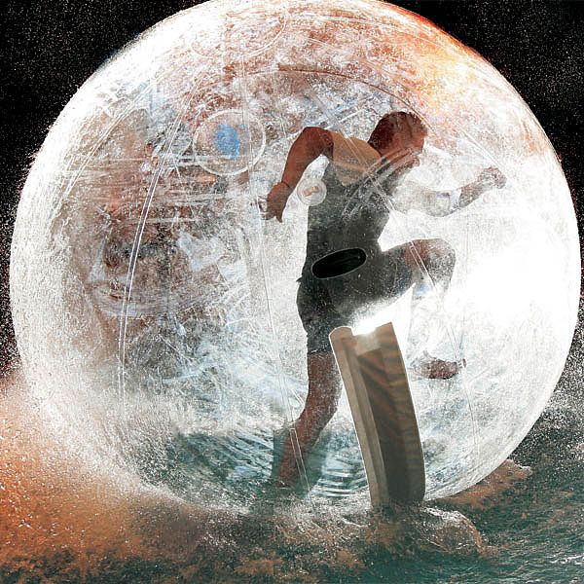 | (3)
 |  | Assessment Standard 2.1 and 2.2 and 1.4 cont’d
Q10 |  | At the end of Autumn when the cylindrical grain silo is full, the farmer has to deliver the grain to his suppliers. How many full trucks can the farmer fill from the silo? The radius of the silo is 5m and its height is 30m.
 |  | 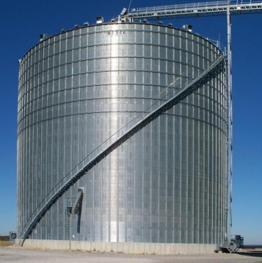
 |  | The trucks have cuboid trailers to maximise volume. The dimensions of the truck are 2m (W), 2m (H) and 6m (L). | (4)
Q11 |  | A Primary 7 class of 24 pupils are making witches hats for Halloween.  The witch hat is made from a conical section as shown below.
 |  | 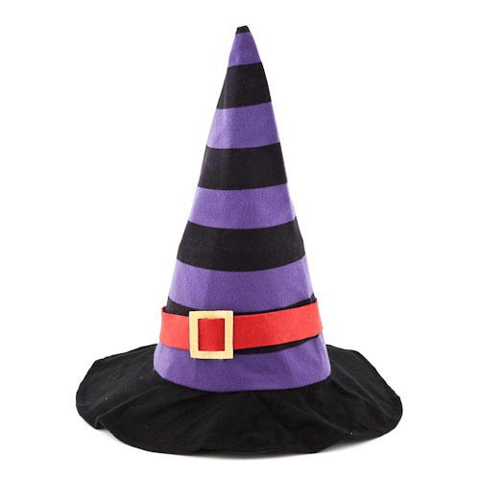
 |  | In the diagram below, the shaded area shows the cardboard used in construction of the witch hat.
205˚
A B
o

AB is a major arc of the circle shown with centre O.

The radius OA is 30 cm.

Angle AOB is 210˚.
 | (a) | Calculate the length of the major arc AB. | (1)
 | (b) | The base of each hat needs attached to the conical part with double sided sticky tape. The tape will be attached to the whole of the base of the cones.  If the teacher buys 30 metres of double sided tape will she have enough for the whole class?  Give a reason and show full working. | (3)

End of question paper

