Lifeskills numeracy homework
1.
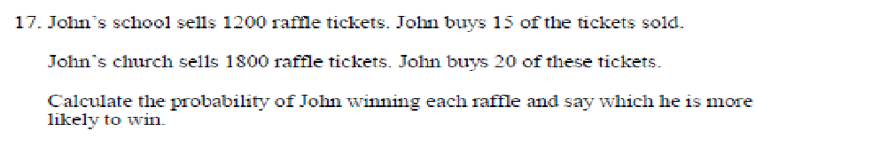
2.
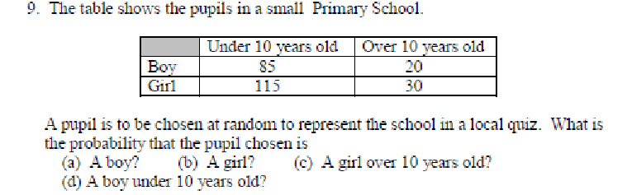

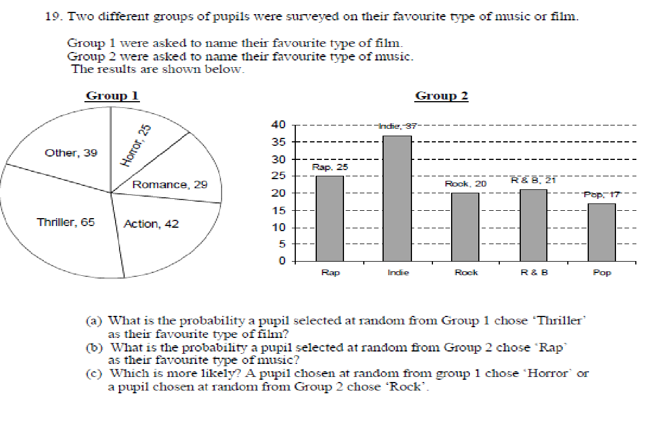
3.

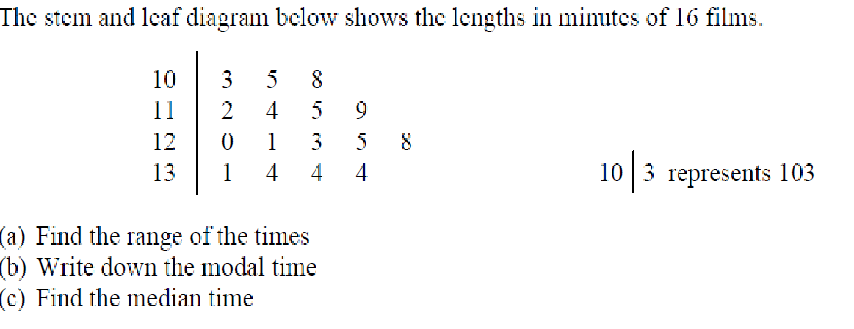
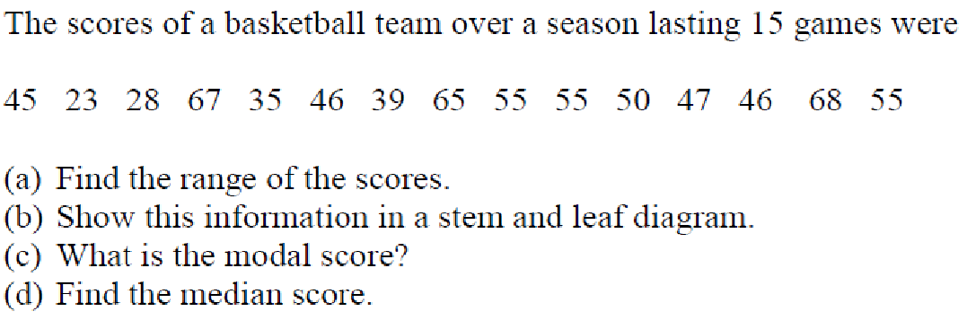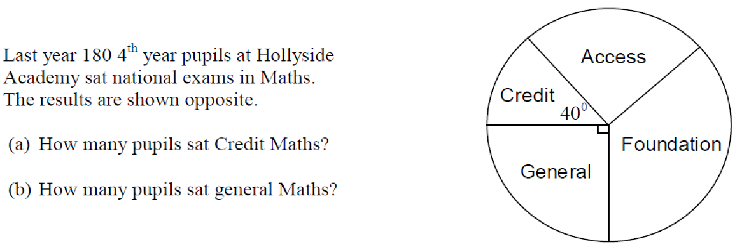
6.
5.
4.
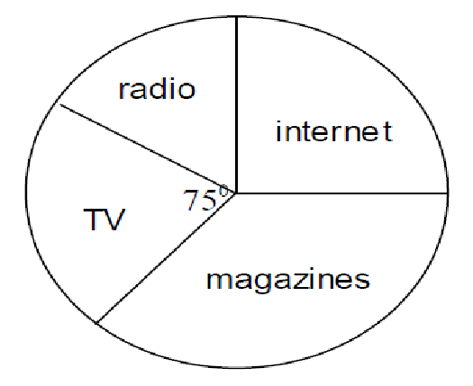
A hotel asks its guests how they found about their business. If 150 of their guests found out about the hotel through the TV. How many guests does the pie chart represent in total? Think carefully about this one.
7.

