1. 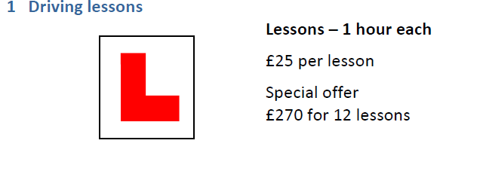For each deal state which offer is better – you must provide a reason why.

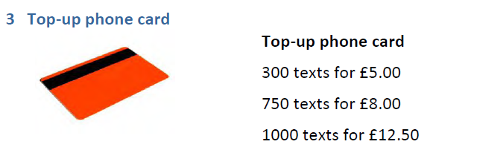

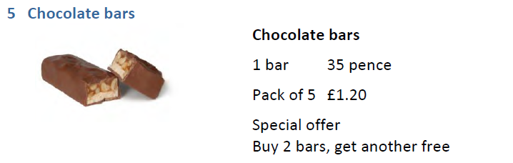

2.

3.

4.

5.





