-

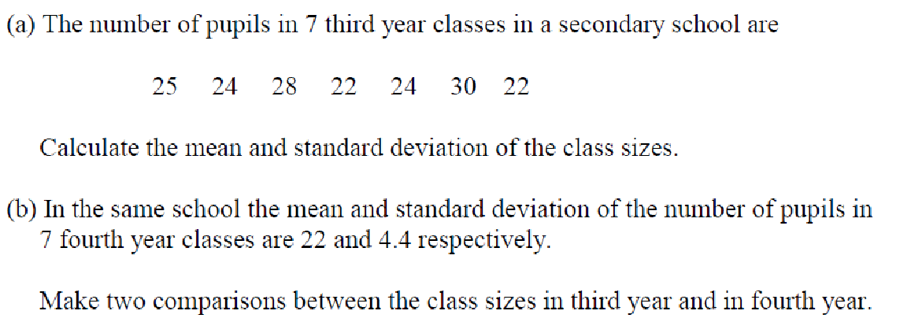

**2.**

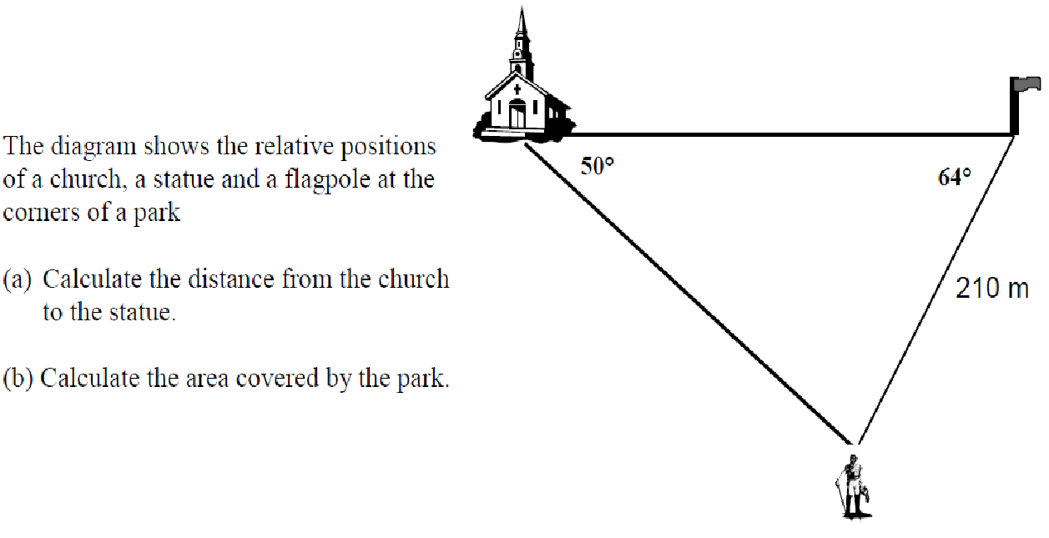

**3.**

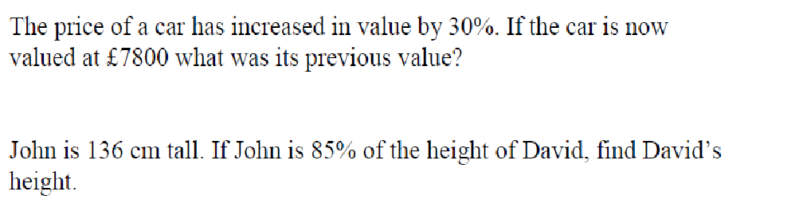

**4.**

**5.**



**6.**

**7.**

C:\Documents and Settings\FORCARSTAIRSL\Local Settings\Temporary Internet Files\Content.IE5\J8KDPEC4\MC900363444[1].wmf