Brackets & Factorising

1. Remove the brackets:

(a) 2(x + 5) (b) a(a + 4b) (c) 2x(3x – 5y)

2. Simplify the following:

(a) 4 + 2(2p – 3q) (b) 2ab + 4a(3a – 2b) (c) 5x – (x + 3y)

3. Multiply out the brackets:

(a) (x + 3)(x + 2) (b) (2y – 3)(y + 4) (c) (a – 3)( $a^{2}+4a-1$)

4. Factorise the following completely:

(a) 6a + 3b (b) 12f + 4g

(c) 2p – 8p² (d) c² – d²

(e) 4x² – 25 (f) 8k² – 18m²

(g) a² + 3a + 2 (h) w² + 3w – 10

(i) y² – 10y + 16 (j) 2t² + 12t – 32

(k) 3p² + 8p – 3

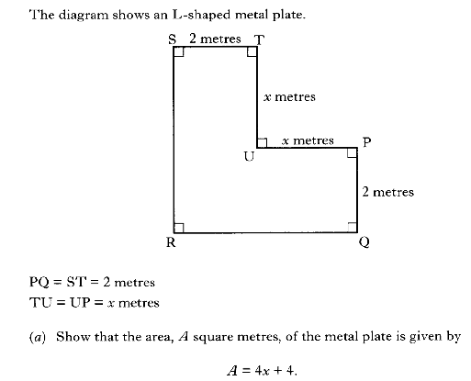
5.

Brackets & Factorising

1. Remove the brackets:

(a) 2(x + 5) (b) a(a + 4b) (c) 2x(3x – 5y)

2. Simplify the following:

(a) 4 + 2(2p – 3q) (b) 2ab + 4a(3a – 2b) (c) 5x – (x + 3y)

3. Multiply out the brackets:

(a) (x + 3)(x + 2) (b) (2y – 3)(y + 4) (c) (a – 3)( $a^{2}+4a-1$)

4. Factorise the following completely:

(a) 6a + 3b (b) 12f + 4g

(c) 2p – 8p² (d) c² – d²

(e) 4x² – 25 (f) 8k² – 18m²

(g) a² + 3a + 2 (h) w² + 3w – 10

(i) y² – 10y + 16 (j) 2t² + 12t – 32

(k) 3p² + 8p – 3

5.

