Clydebank High School

Mathematics Department

Higher

Unit 2 Revision

*Taken from Pegasys Revision Packs*

Differentiation 1

1. Differentiate each of the following with respect to *x* :

(a)  (b)  (c) 

2. Differentiate each of the following functions with respect to the relevant variable :

(a)  (b)  (c) 

(d)  (e)  (f) 

(g)  (h)  (i) 

3. Calculate the rate of change of :

(a)  at  (b)  at 

4. The amount of pressure *P* (pounds per square inch) within a cylinder varies with

time *t* (milliseconds) according to the formula  .

(a) Calculate the rate of change of *P* when  .

(b) Calculate how fast *P* is changing when  .

(c) How is the rate of  *P* changing when  ? Comment.

5. (a) Find the equation of the tangent to the curve with equation  at

the point where  .

(b) Find the equation of the tangent to the curve at the point where .

6. A function *f* is given by . Determine the interval on which *f* is increasing.

7. Find the stationary points of the curve  and determine their nature.

8. A curve has as its equation  .

X3 c (a) Find the stationary points of the curve and determine the nature of each.

(b) Write down the coordinates of the points where the curve meets the coordinate axes.

(c) Sketch the curve.

Differentiation 2

1. Differentiate, expressing your answers with positive indices :





2. Differentiate, expressing your answers with positive indices :



3. A curve has as its equation  , where  .

Find the equation of the tangent to this curve at the point where  .

4. A curve has as its equation .

(*a*) Find the exact value of *y* when  .

(*b*) Find  and evaluate it for  .

(*c*) Hence show that the equation of the tangent to the curve at the point where

 can be written in the form  .



5. A rectangular field is *x* metres long. It is enclosed by 200 metres

*x*

of fencing.

(*a*) Find an expression in terms of *x*  for the breadth of the field .

(*b*) Hence find the greatest area which can be enclosed with the 200 metres of fencing.

6. An open cistern with a square base and vertical sides is to have a

*x*

*x*

*h*

capacity of 4000 cubic feet.

(*a*) Taking the length of the square base to be *x* feet , find an

expression for the height *h* in terms of *x* .

(*b*) Hence show that the surface area, *A* square feet, of the cistern

can be written in the form



(*c*) Find the dimensions of the cistern so that the cost of cladding it in lead sheet will

be a minimum.

Trig. Equations

1. Solve each of the following equations :

(*a*) 

(*b*) 

(*c*) 

(*d*) 

2. Solve each of the following equations for  :

 (*b*) 

(*c*)  (*d*) 

3. Solve the equation  .

4. Solve  .

5. Solve the equation  .

6. (*a*) Express  in the form  ,

and write down the values of  *P* , *Q* and *R* .

(*b*) Hence solve the equation  , for  .

7. The diagram opposite shows a rectangular rocket launcher

*ABCD* . The launcher is hinged at point A. The sliding rod

*PC* has been fixed such that *APC*  .

*AB* = 60 *cm*  and *BC* = 20 *cm* and  as shown.



*h cm*

60 *cm*

20c*m*

*x*

*y*

*A*

*B*

*C*

*D*

*P*

(*a*) Use the diagram to show that the height of *C* above

*XY* can be expressed as

H = 60sin*θ* + 20cos*θ*

(*b*) Given that , calculate the size of angle

 to the nearest degree.

The Wave Function ()

1. (a) Express  in the form  , where *k* and  are

constants and *k* > 0.

(b) Hence state the minimum value of the function  *f* given that

 , and the corresponding replacement for  *x* .

2. The formula  represents the height, in metres, of a

wave-power boom above the sea bed at time  *t* hours after midnight.

(a) Express *h* in the form  + 25 .

(b) What is the booms minimum height above the sea bed and at what time

does this minimum clearance occur ?

(c) Sketch the graph of *h* against *t* for  , showing clearly all relevant points.

(d) The boom generates the most power when it is 27 metres or more above the sea bed.

For what length of time is this ideal situation in operation ?

Give your answer correct to the nearest minute.

3. The diagram opposite shows an A-Frame used to support an

*P*

*S*

*Q*

*T*

*R*



1

2

3

inspection platform on an North Sea oil-rig.

Angle *SQT* is a right-angle,  and all lengths

are in metres.

(a) Show that the length of *RQ* is given as  and

*PQ* as  .

*ST is parallel to PR*

(b) Hence express  in the form  and

write down the values of *a* , *b* and *c* .

(c) Find the maximum length of *PR* and the corresponding value

of  . Give your answers correct to 1 d.p.

4. (a) Show that  can be written as  .

(b) Express  in the form  where *k* > 0 and

 is acute, and write down the values of *k* and .

(c) Hence solve the equation  = 1 for  .

5. The diagram below shows two right-angled triangles.   
Find the exact value of .

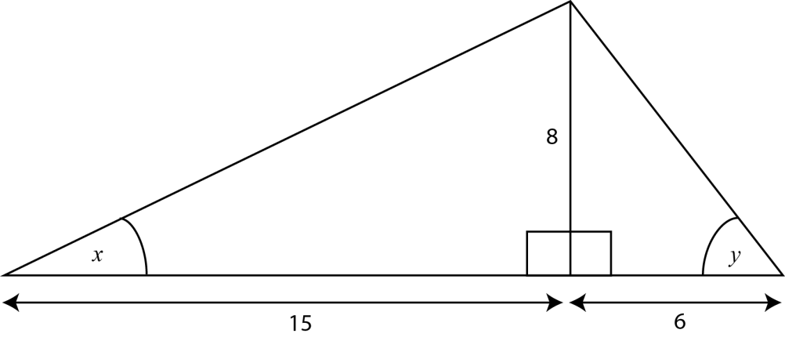

3

111

5

6. Show that .

*Answers*

Differentiation 1 (answers)

1. 

2. 



 

3. *(a)* 4 *(b)* 

4. *(a)* 200 *(b)* 0 *(c)*  (pressure is decreasing)

5. 

6. *f* is increasing when 0 < *x* < 1 .

7. (-2,32) , *Max.* , (0,0) ,  *Min.* , (1,5) , *Max.*

8. *(a)* 

*(b)* ( 0 , 0 ) and ( 2 , 0 )



*(c)*

Differentiation 2 (answers)

1. 



2. 



3. 

4.   (c) Proof

5. (*a*) 

(*b*) 2500 square metres

6. (*a*) 

(*b*) Proof

(*c*) 20 by 20 by 10 (since 

Trig. Equations (answers)

*All answers in degrees except 1(b) and 4.*

1. (a)  (b) 

(c)  (d) 

2. (a)  (b) 

(c)  (d) 

3. 

4. 

5. 

6. (a) 

(b) 

7. (a) Proof

(b) 

The Wave Function [] (answers)

1. (a) 

(b) min. of 2 @ 

2. (a) 

(b) 20 metres @ 14 28

30

29

2.46

14.46

24

*t hours*

*h metres*

20

(c)



(d) 8 hours 51 minutes (from 2202 until 0653)

3. (a) Proof

(b) 

(c) 

4. (a) Proof

(b)  , 

(c) {  }

5.  or 

6. Proof