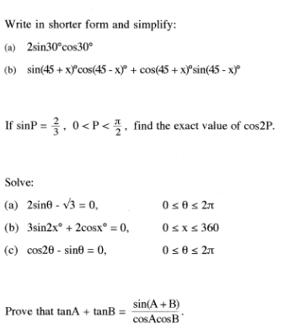

4.

3.

2.

1.

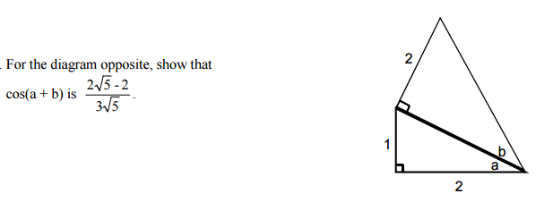**2.**

5.

6.

**5.** (*a*) Solve the equation  for.

(*b*) The diagram below shows parts of the graph of two cosine functions, *h* and *k*.

State expressions for *h*(*x*) and *k*(*x*).

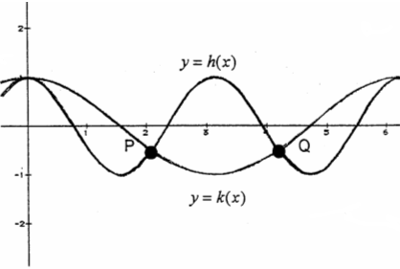

(*c*) Use your answers to part (a) to find the coordinates of P and Q.

(*d*) Hence state the values of x in the interval  for which.