Formal Exercise 7 Trigonometry

Questions 1 – 8 should be completed without the use of a calculator
Your teacher may select some or all of this to do.

1. What is the exact value of sin $(\frac{π}{3})$ – cos $(\frac{5π}{4})$? (3)

2. Solve the following equations
a) √2cosxº + 1 = 0 0 < x < 360 (2)
b) 2sin(x + $\frac{π}{3}$ ) - √3 = 0 0 ≤ x ≤ 2π (3)
c) 2cos²x – cosx – 1 = 0 0 ≤ x ≤ 2π (4)
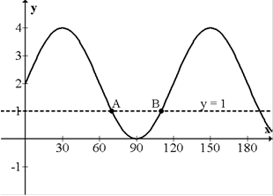

3. (a) The diagram opposite shows the graph of
y = psin qx + r.
Write down the equation of this graph.

(b) The line y = 1 is drawn on the same graph.
Find the coordinates of A and B.

(2,3)

4. Sketch the graph of y = 3cos4x – 1 0 ≤ x ≤ π (3)

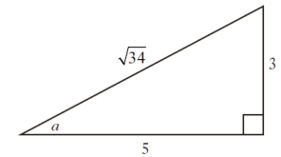
5. A right angled triangle has sides and angles as shown in the diagram.
What is the exact value of sin 2a?

(2)
6. If the exact value of cos x is $\frac{1}{√5}$, find the exact value of cos 2x. (3)
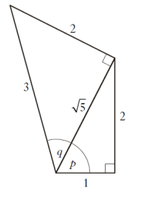
.

7. The diagram opposite shows two right (3)
angled triangles with sides and angles given.
What is the exact value of sin(p + q)?

8. Solve 2cos2x – 5cosx – 4 = 0 0 ≤ x ≤ 2π (5)

9. Solve 4sin2$θ$ = 5sin$θ$ 0 ≤ x ≤ 2π (5)

10. a) Using the fact that $\frac{7π}{12}$ = $\frac{π}{3}$ + $\frac{π}{4}$, find the exact value of sin ($\frac{7π}{12})$ (3)

b) Show that sin(A + B) + sin(A – B) = 2sinAcosB (2)

c) i) Express $\frac{π}{12}$ in terms of $\frac{π}{3}$ and $\frac{π}{4}$
ii) Hence or otherwise, find the exact value of sin$(\frac{7π}{12})$ + sin($\frac{π}{12})$ (4)

47 MARKS

