Formal Exercise 4 - Polynomials

1. (a) Show that $(x – 4)$ is a factor of: $x^{3} – 4x^{2}– x + 4$.

(b) Hence factorise $x^{3}–4x^{2}–x+4$ fully. (4)

2. (a) Given $(x+2)$ is a factor of $2x^{3} + x^{2} + kx + 2$,

find the value of *k*. (3)

(b) Hence solve the equation: $2x^{3}+{ x}^{2} + kx + 2= 0$,

when *k* takes this value. (2)

3. (a)

Given $(x-1)$ and $(x+5)$ are both factors of $f\left(x\right),$ find $c$ and $d$.

(5)

(b) Hence solve $f(x) = 0$ when $c$ and $d$ take these values.

(2)



The tangent to the curve:

$y = x^{3} – 7x + 6$ at the point $(-1, 12)$ has equation: $y + 4x = 8.$

Find the coordinates of the other point of intersection of the curve and this tangent.

4.

(6)

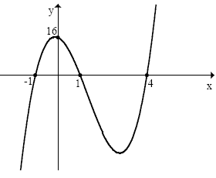

The function opposite has roots of:

$x=–1, 1$ and $4$ and it crosses the y-axis at the point (0,16).

Find the equation of this function.

5.

(4)

6. A quadrilateral has vertices $A(–1, 8), B(7, 12), C(8, 5)$ and $D(2, –3)$ as shown in the diagram below.

(a) Find the equation of diagonal BD.

(2)

(b) The equation of diagonal AC is $x + 3y = 23$.

Find the coordinates of E, the point of intersection of the diagonals.

(2)

(c) (i) Find the equation of the perpendicular bisector of AB.

(3)

(ii) Show that this line passes through E.

(1)

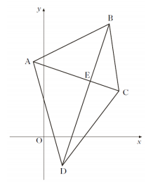

(=34 marks)