Forfar Academy Mathematics Department

Remember to show all you working:

- Which offer is the best value? Why?
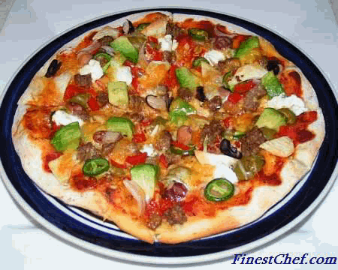
1 x 30 cm (diameter) pizza for £14.99 | 2 x 18 cm (diameter) pizzas for £14.99

- What is the relationship between the radius and the diameter of a circle?

- . Calculate the perimeter of the logo below:
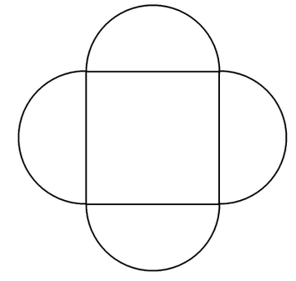

3.1 cm

3.7 cm
- Find the shaded area: | - Find the area of the ring:
5.6 cm
1.7 cm

